Given an ascending sorted rotated array **arr**of distinct integers of size **n**. The array is right-rotated **k** times. Find the value of **k**.

**Example 1:**

**Input:**

n = 5

arr[] = {5, 1, 2, 3, 4}

**Output:** 1

**Explanation:** The given array is 5 1 2 3 4.

The original sorted array is 1 2 3 4 5.

We can see that the array was rotated

1 times to the right.

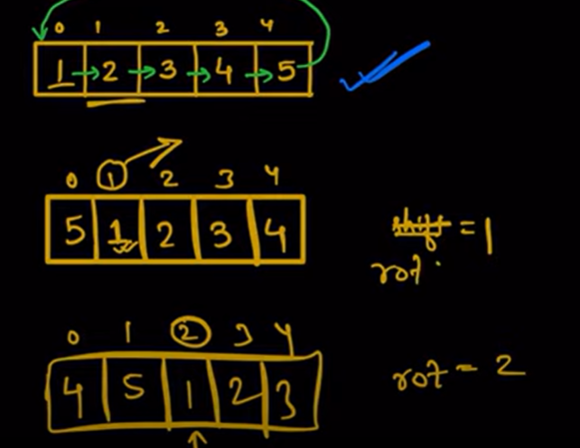

Basically we need to find the index of smallest element